Name – Harshit

MIS – 112316018

Java Lab

Assignment 3

1. Using for loop, write a program that prints out the  
   decimal equivalents of 1/2, 1/3, 1/4, . . . , 1/10.

Code :

1. // Source code is decompiled from a .class file using FernFlower decompiler.
2. public class DecimalEquivalent {
3. public DecimalEquivalent() {
4. }
5. public static void main(String[] var0) {
6. System.out.println("Decimal equivalents of fractions from 1/2 to 1/10:");
7. for(int var1 = 2; var1 <= 10; ++var1) {
8. double var2 = 1.0 / (double)var1;
9. System.out.println("1/" + var1 + " = " + var2);
10. }
11. }
12. }

Output:

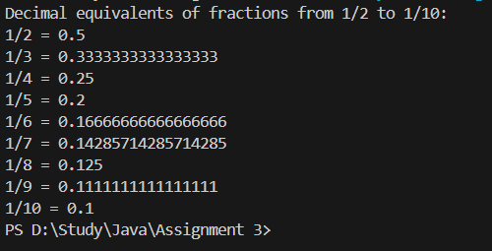  
  
2) Write a program using a while loop that asks the user for  
a number, and prints a countdown from that number to zero.  
Code :

import java.util.Scanner;

public class Countdown {

    public static void main(String[] args) {

        Scanner scanner = new Scanner(System.in);

        System.out.print("Enter a number to start the countdown: ");

        int number = scanner.nextInt();

        System.out.println("Countdown:");

        while (number >= 0) {

            System.out.println(number);

            number--;

        }

        scanner.close();

    }

}

Output:

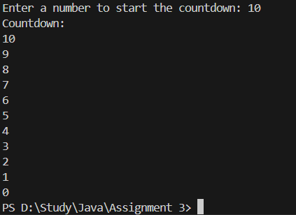  
  
3) Write a java program to find largest of three numbers.  
Code:

import java.util.Scanner;

public class LargestOfThree {

    public static void main(String[] args) {

        Scanner scanner = new Scanner(System.in);

        System.out.print("Enter the first number: ");

        int num1 = scanner.nextInt();

        System.out.print("Enter the second number: ");

        int num2 = scanner.nextInt();

        System.out.print("Enter the third number: ");

        int num3 = scanner.nextInt();

        int largest = (num1 > num2)

            ? ((num1 > num3) ? num1 : num3)

            : ((num2 > num3) ? num2 : num3);

        System.out.println("The largest number is: " + largest);

        scanner.close();

    }

}

Output

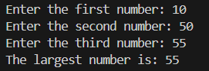

4) Write a java program that prints prime numbers less than  
20.  
Code :

public class PrimeNumbers {

    public static void main(String[] args) {

        System.out.println("Prime numbers less than 20:");

        for (int num = 2; num < 20; num++) {

            boolean isPrime = true;

            for (int i = 2; i <= Math.sqrt(num); i++) {

                if (num % i == 0) {

                    isPrime = false;

                    break;

                }

            }

            if (isPrime) {

                System.out.print(num + " ");

            }

        }

    }

}

Output:

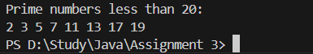

5) Write a program that accepts the lengths of three sides  
of a triangle as inputs. The program output should indicate whether or not the  
triangle is a right triangle (Recall from the Pythagorean Theorem that in a  
right triangle, the square of one side equals the sum of the squares of the  
other two sides).  
Code :

import java.util.Scanner;

public class RightTriangleCheck {

    public static void main(String[] args) {

        Scanner scanner = new Scanner(System.in);

        System.out.print("Enter the first side: ");

        int a = scanner.nextInt();

        System.out.print("Enter the second side: ");

        int b = scanner.nextInt();

        System.out.print("Enter the third side: ");

        int c = scanner.nextInt();

        if (a > b && a > c) {

            int temp = c; c = a; a = temp;

        } else if (b > c) {

            int temp = c; c = b; b = temp;

        }

        if (c \* c == a \* a + b \* b) {

            System.out.println("The triangle is a right triangle.");

        } else {

            System.out.println("The triangle is NOT a right triangle.");

        }

        scanner.close();

    }

}

Output:

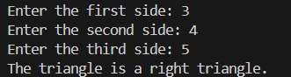

6) Write a java to find the best of two test average marks  
out of three test’s marks accepted from the user.

Output:

import java.util.Scanner;

public class BestTwoAverage {

    public static void main(String[] args) {

        Scanner scanner = new Scanner(System.in);

        System.out.print("Enter marks for Test 1: ");

        int test1 = scanner.nextInt();

        System.out.print("Enter marks for Test 2: ");

        int test2 = scanner.nextInt();

        System.out.print("Enter marks for Test 3: ");

        int test3 = scanner.nextInt();

        int smallest = Math.min(test1, Math.min(test2, test3));

        int bestTwoSum = test1 + test2 + test3 - smallest;

        double bestTwoAverage = bestTwoSum / 2.0;

        System.out.println("The average of the best two marks is: " + bestTwoAverage);

        scanner.close();

    }

}

Output:

